Mobile Apps

Development Report **[your mobile app name]**

Prepared by

NAME :

MATRIC NO :

GROUP :



Table of Contents

1.0 Project Background ..........................................................................................................2 2.0 Problem Statement ...........................................................................................................2 3.0 Project Objective ..............................................................................................................2 4.0 Project Scope ...................................................................................................................2 5.0 Features of the App ..........................................................................................................2 6.0 Related Mobile App ..........................................................................................................3 7.0 Application Design ............................................................................................................3 8.0 App User Flow ..................................................................................................................3 9.0 Project Timeline ................................................................................................................4

1



**1.0 Project Background**

Each of you need to create a mobile application that incorporates data processing (calculation), TinyDB database management, and pertinent content to the application's goals.

Example : The proposed development of a mobile phone app by the Computer Science department would serve many perceived needs across campus. Students require additional ways to keep in touch while on the go with campus events, news alerts, accessing campus directories and maps, and many other features. The development of a mobile phone app would also serve the Computer Science class by providing them real-world opportunities to develop marketable skills in mobile app development.

Idea: To do List task app, event management app, weight management app, healthy food app.

**2.0 Problem Statement**

What is the problem that you want to solve?

Example:

**3.0 Project Objective**

State your objective in numbering form.

Example: 1. To develop an application that organize work and life.

**4.0 Project Scope**

Describe your application's limitations, including its target audience, the function's precise objective, and more.

**5.0 Features of the App**

Example : While the features of the mobile phone app will still need to be decided upon, universities are typically utilizing the following features:

• A calendar of club and organization events on campus

• Map service based on the GPS location of the user

2



• News feed

• Athletics information

• Campus directory

**6.0 Related Mobile App**

Choose any two existing and similar mobile apps and compare and contrast their features and functions, user interfaces, and interactivity.

**7.0 Application Design / Storyboard**

A storyboard is a tool for pre-visualizing your video project shot by shot before creating a detailed plan. A project that begins the pre-production process by creating a storyboard is more likely to avoid blunders caused by miscommunication during production, for example,

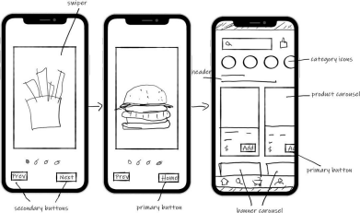Sample of storyboard design

3



**8.0 App User Flow**

Example

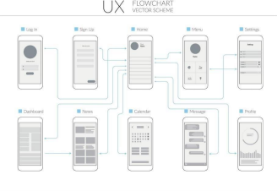

**9.0 Project Timeline**

example

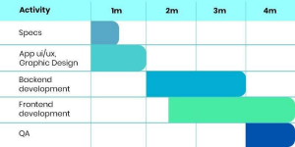

4

5